How to 360 sound design; the Julian way
Tools Needed:
Reaper(I am using 5.32): http://www.reaper.fm/download.php
Facebook 360 spatial workstation https://facebook360.fb.com/spatial-workstation/
Spooksync VR http://www.spook.fm/spooksyncvr/
GoProVR http://www.kolor.com/gopro-vr-player/
VVMicVST (if using tetramic) https://www.vvaudio.com/products/vvmicvst
Python 2.7 https://www.python.org/downloads/release/python-2712/
Mp4Box https://gpac.wp.imt.fr/downloads/
Your choice of mic/recording (Tetramic/H2zoom, etc)

Step 1: Acquire Recording
Take your tetramic, zoom, iphone, what have you, and record the sound you are looking for. If you are recording on the tetramic or any ambisonic mic, you will be recording in B-format (I’ll talk about what this means later). If you are recording in any other format, make sure to mix down your recording to mono.
Step 2: Setting up Facebook 360 Spatial Workstation:
In the FB360 spatial workstation folder, there is a great reaper template which already has a 3D master, Control Plugin, Head locked master and a bunch of pre-set tracks used for either B-format spatialization or mono spatialization. I recommend using this as a jumping off point. Open up this template. It will probably look like this:
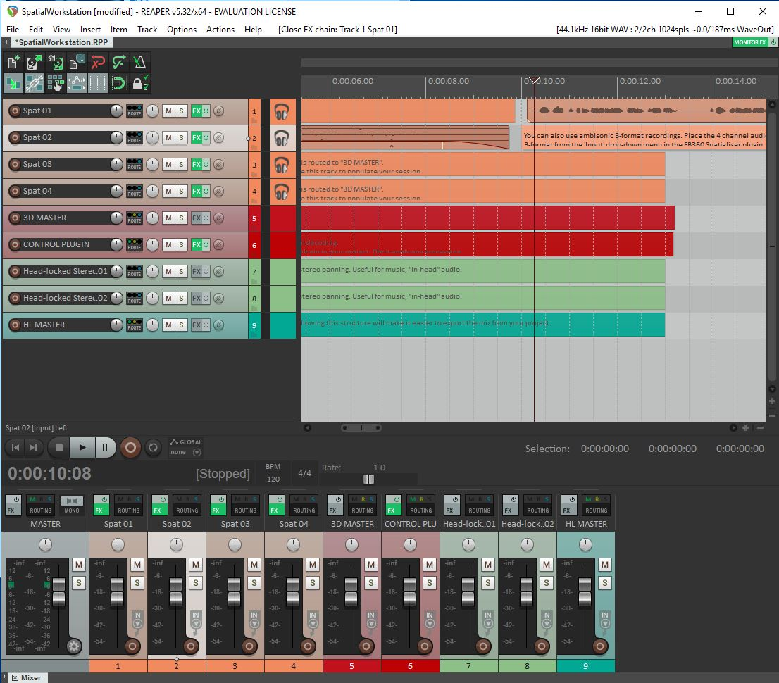

Step 3A: Working with B-Format
Take your B-format recording and place it in one of the “Spat” tracks. Click on FX
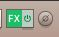
Change the input from left to B-Format (FuMa)
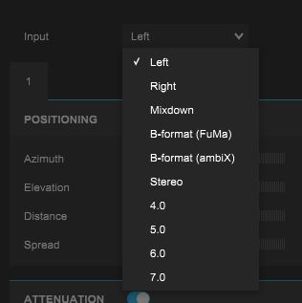
This will easily decode your B-format and translate it to positional sound. Still, all ambisonic mics are different and each has its own VST to make up for each of the differences. The tetramic has it’s own VST called the Visual virtual tetramic. Along with that, each has it’s own calibrations. In the top left of this FX page, click “FX” and scroll down to “Add FX.” Search for the Visual virtual tetramic VST, chain it before the FB360 Spatialiser VST, like this:
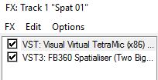
Make sure you have the correct calibrations for your mic, and you are all set to go.

Step 3B: Working with Mono
This step seems deceptively easy, but leads to some substantial problems. First, import your mono sound onto one of the “spat” tracks. Again, click on the FX button and, this time; make sure the input is set to “left.” In this Fx window, you can adjust the azimuth, elevation, and distance.
Azimuth(position around the viewer):
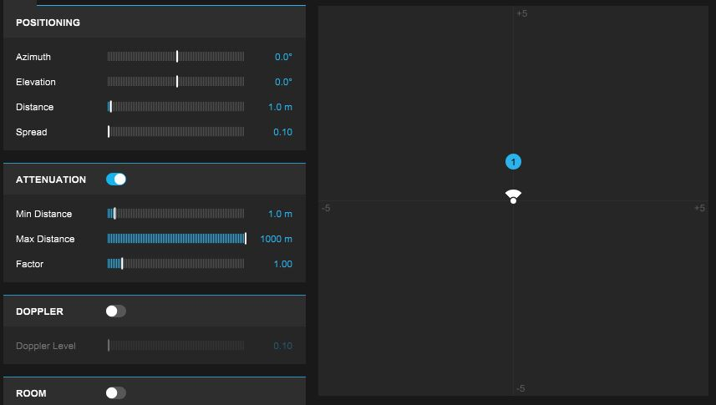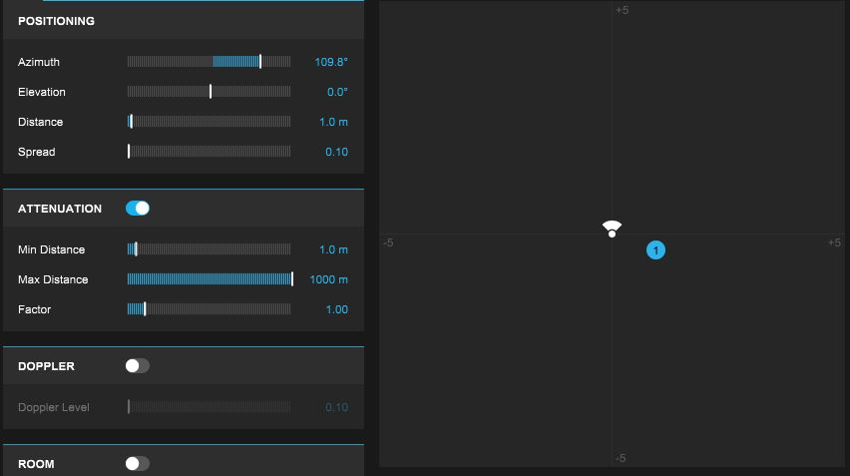
Distance:
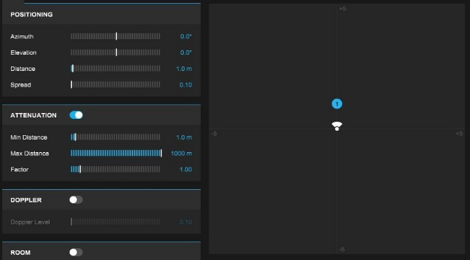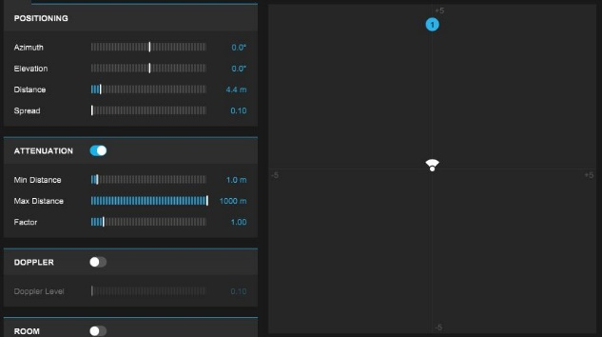
A couple words of wisdom: Elevation does very little in this particular iteration of Fb360 workstation, so I would not play around too much with it unless you really know what you want. Also, if you want to upload your video to be viewable on gear VR or Daydream, I would keep all the distances the same (again, unless you really know what you are doing). It really screws with the positional values of the gear VR and Daydream otherwise (it is easy to create the same effect of distance through filters and volume changes).

Step 4: Editing in 360
This is the annoying step. Most likely, if you are working with mono sounds you will need some type of visual references (360 video file, oculus) in order to know if your sounds are correctly positioned. Unfortunately, the video player that comes with the fb360 workstation seems to have trouble working with files over 2MB by crashing, not loading, and leaving a lot to be desired. I have not found a way to use this video player efficiently, but if you do, amazing! Please tell me how! I devised my own way to do so. First, open up Spooksync VR.
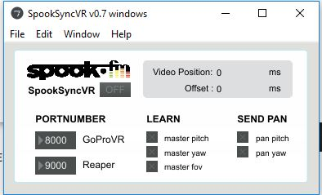
Spooksync allows you to get the pitch yaw and fov(roll) of GoProVR and translate it to be whatever you like in Reaper.
Make sure that the port number of GoProVR is 8000. This can be changed in “preferences and then under the “master/slave” section.
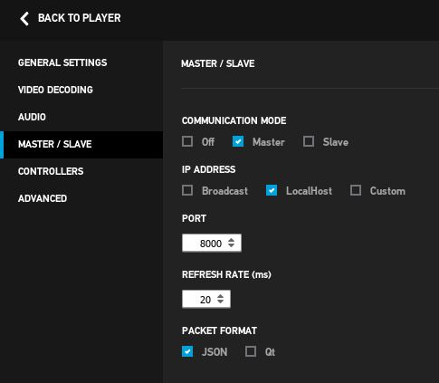
Now make sure that the Reaper Port is set to 9000. This can be found under “Options,” “Preferences,” then scroll to “Control/OSC/web.” In this press “Add,” and make sure Reaper receives on port 9000
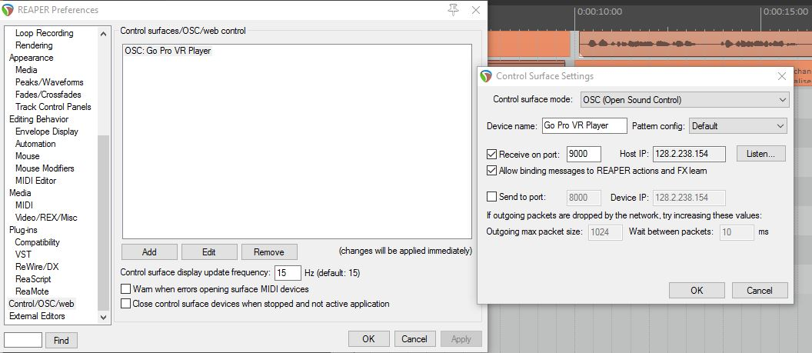
Now, if Spooksync is working, you should see a green dot by the GoProVR

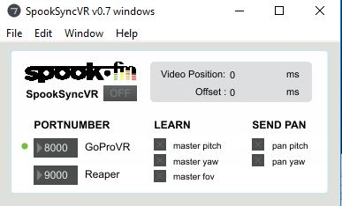
If this doesn’t show up, my highly technically advice would be to close GoproVR and open it again a couple of times.
Now, you’ll want to make Reaper “learn” the yaw and pitch (fov or zoom wont matter as much here). The way you’ll do this is by turning on SpooksyncVR and clicking the x under “learn master yaw”
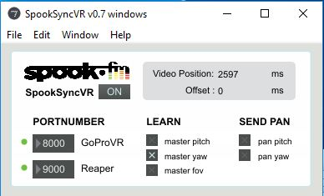

Next, go the CONTROL PLUGIN track, click trim, then click the “learn” button next to the Listener Yaw function. It will ask for command yaw, in which you will respond yes.
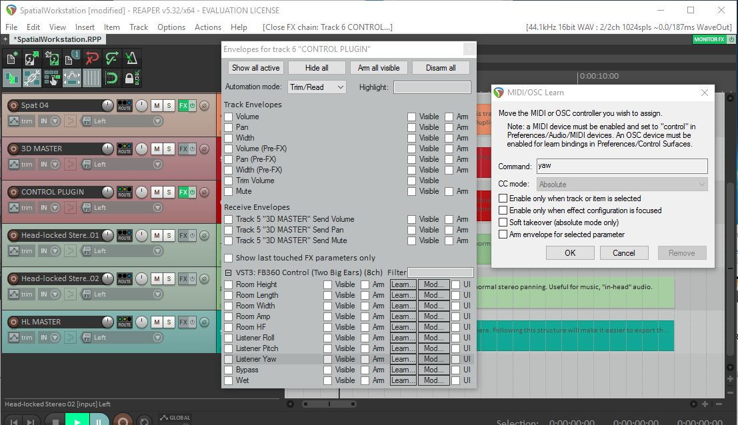
Now you will have learned the yaw. You will do the same process, but instead unchecking master yaw in spooksync and instead checking master pitch. You will also click the learn of Listener Pitch instead of Listener Yaw, and will be prompted by pitch.
Great! Recheck both master pitch and yaw in spooksync and now reaper should be synced to GoProVR, allowing you to edit your sounds to the video.

Step 5: Rendering and Encoding
At this point, you’ve hopefully finished your editing and want to upload your sound track for the whole world to hear. Click on the 3D MASTER track, and make sure this is the ONLY ONE CHECKED. Next, go to file and select Render. Make sure under source it says, “Stems (selected tracks).” Also make sure the sample rate is 44100 and the amount of channels in 8. Next click render.
Now we open the encoder supplied to us in the facebook 360 spatial workstation folder. Depending on whether you are uploading it to youtube or Fb360, your selected output format will be different. Next, under “Spatial audio” make sure “Spatial Workstation 8 channel” is selected and load the file you just rendered in the spatial audio file. Lastly, for video, make sure the video layout is monoscopic and load your video file in.

Upload to youtube or facebook 360 and Congrats! You’re all set!

